Algebra 3-4 Name: ______________________
Quiz Block: _____

For problems 1 – 6, factor the expression completely.

1. m² – 9m + 20 2. 4u² – 4u – 35 3. 25n² – 49

4. 16m² – 24m + 9 5. 7y³ + 2y² – 6y 6. 15x² – 6x – 21

For problems 7 -12, simplify the expression.

7. 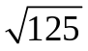 8. 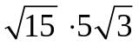 9. 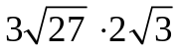

10. 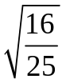 11. 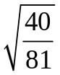 12. 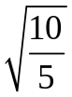

For problem 13, select the correct answer.

13. Find the value of x, knowing the area of the rectangle is 15 in².

A. x = 0 in and x = 4 in
x in

B. x = 1 in and x = 3 in

C. x = 1 in and x = 4 in
(20 – 5x) in
D. x = 5 in and x = 20 in
For problems 14 – 22, solve the equation.

14. x² + 10x + 21 = 0 15. 3x² – 24x – 27 = 0

16. x² – 8x = -15 17. 8k² + 5k = 2k² + 4

18. 9r² + 30r + 25 = 0 19. 16y² – 80y = 0

20. x² = 289 21. 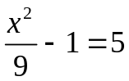

22. 